**User Manual:**

**Listen and Don’t Forget Bro!**

**Game Description**

Listen and Don’t Forget Bro! is an FPGA-based memory game that is a cooperative experience between two players. One player will be designated as the bomb defuser while a second player will act as the bomb defuser’s assistant. The defuser will have access to the FPGA and will manipulate a set of switches and buttons based on what is being seen on five seven segment displays. The assistant will have the guide to defusing the bomb and will tell the defuser how to act based on the different situations they are given. The first thing the defuser must do when operating the game is to press the reset button as this will allow the game to initialize. Next, they will enter their assigned game ID and password or will use the guest account to log into the game. After login has been completed, they will then set the difficulty level and begin playing.

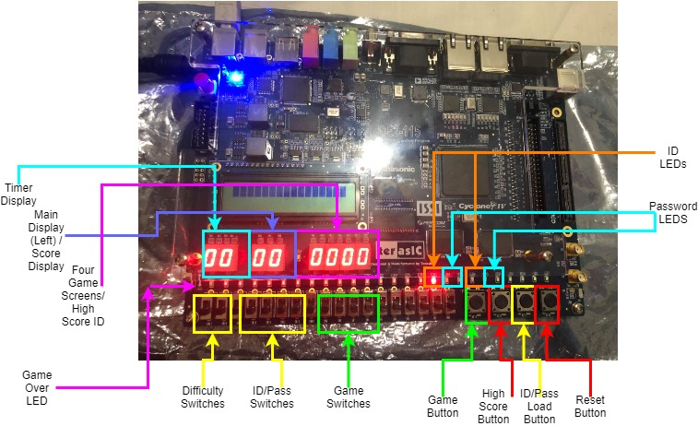

Figure 0. Board Layout

Based on what the user sees in the five segment displays shown above in Figure 0, the user will set their switches accordingly following the instruction set below. They will flip the corresponding switch as well as press the game button to make their selection.

Stage 1:

If the display is 0, flip up the 2nd switch.

If the display is 1, flip up the 2nd switch.

If the display is 2, flip up the 3rd switch.

If the display is 3, flip up the 4th switch.

Stage 2:

If the display is 0, flip up the switch under display showing “3”.

If the display is 1, flip up the switch that was set in Stage 1.

If the display is 2, flip up the 1st switch.

If the display is 3, flip up the 2nd switch.

Stage 3:

If the display is 0, flip up the switch you flipped in Stage 2.

If the display is 1, flip up the switch you flipped in Stage 1.

If the display is 2, flip up the 3rd switch.

If the display is 3, flip up switch under display showing “3”.

Stage 4:

If the display is 0, flip up the switch you flipped in Stage 1.

If the display is 1, flip up the 1st switch.

If the display is 2, flip up the switch you flipped in Stage 2.

If the display is 3, flip up the switch you flipped in Stage 3.

**Game Instructions / Rules**

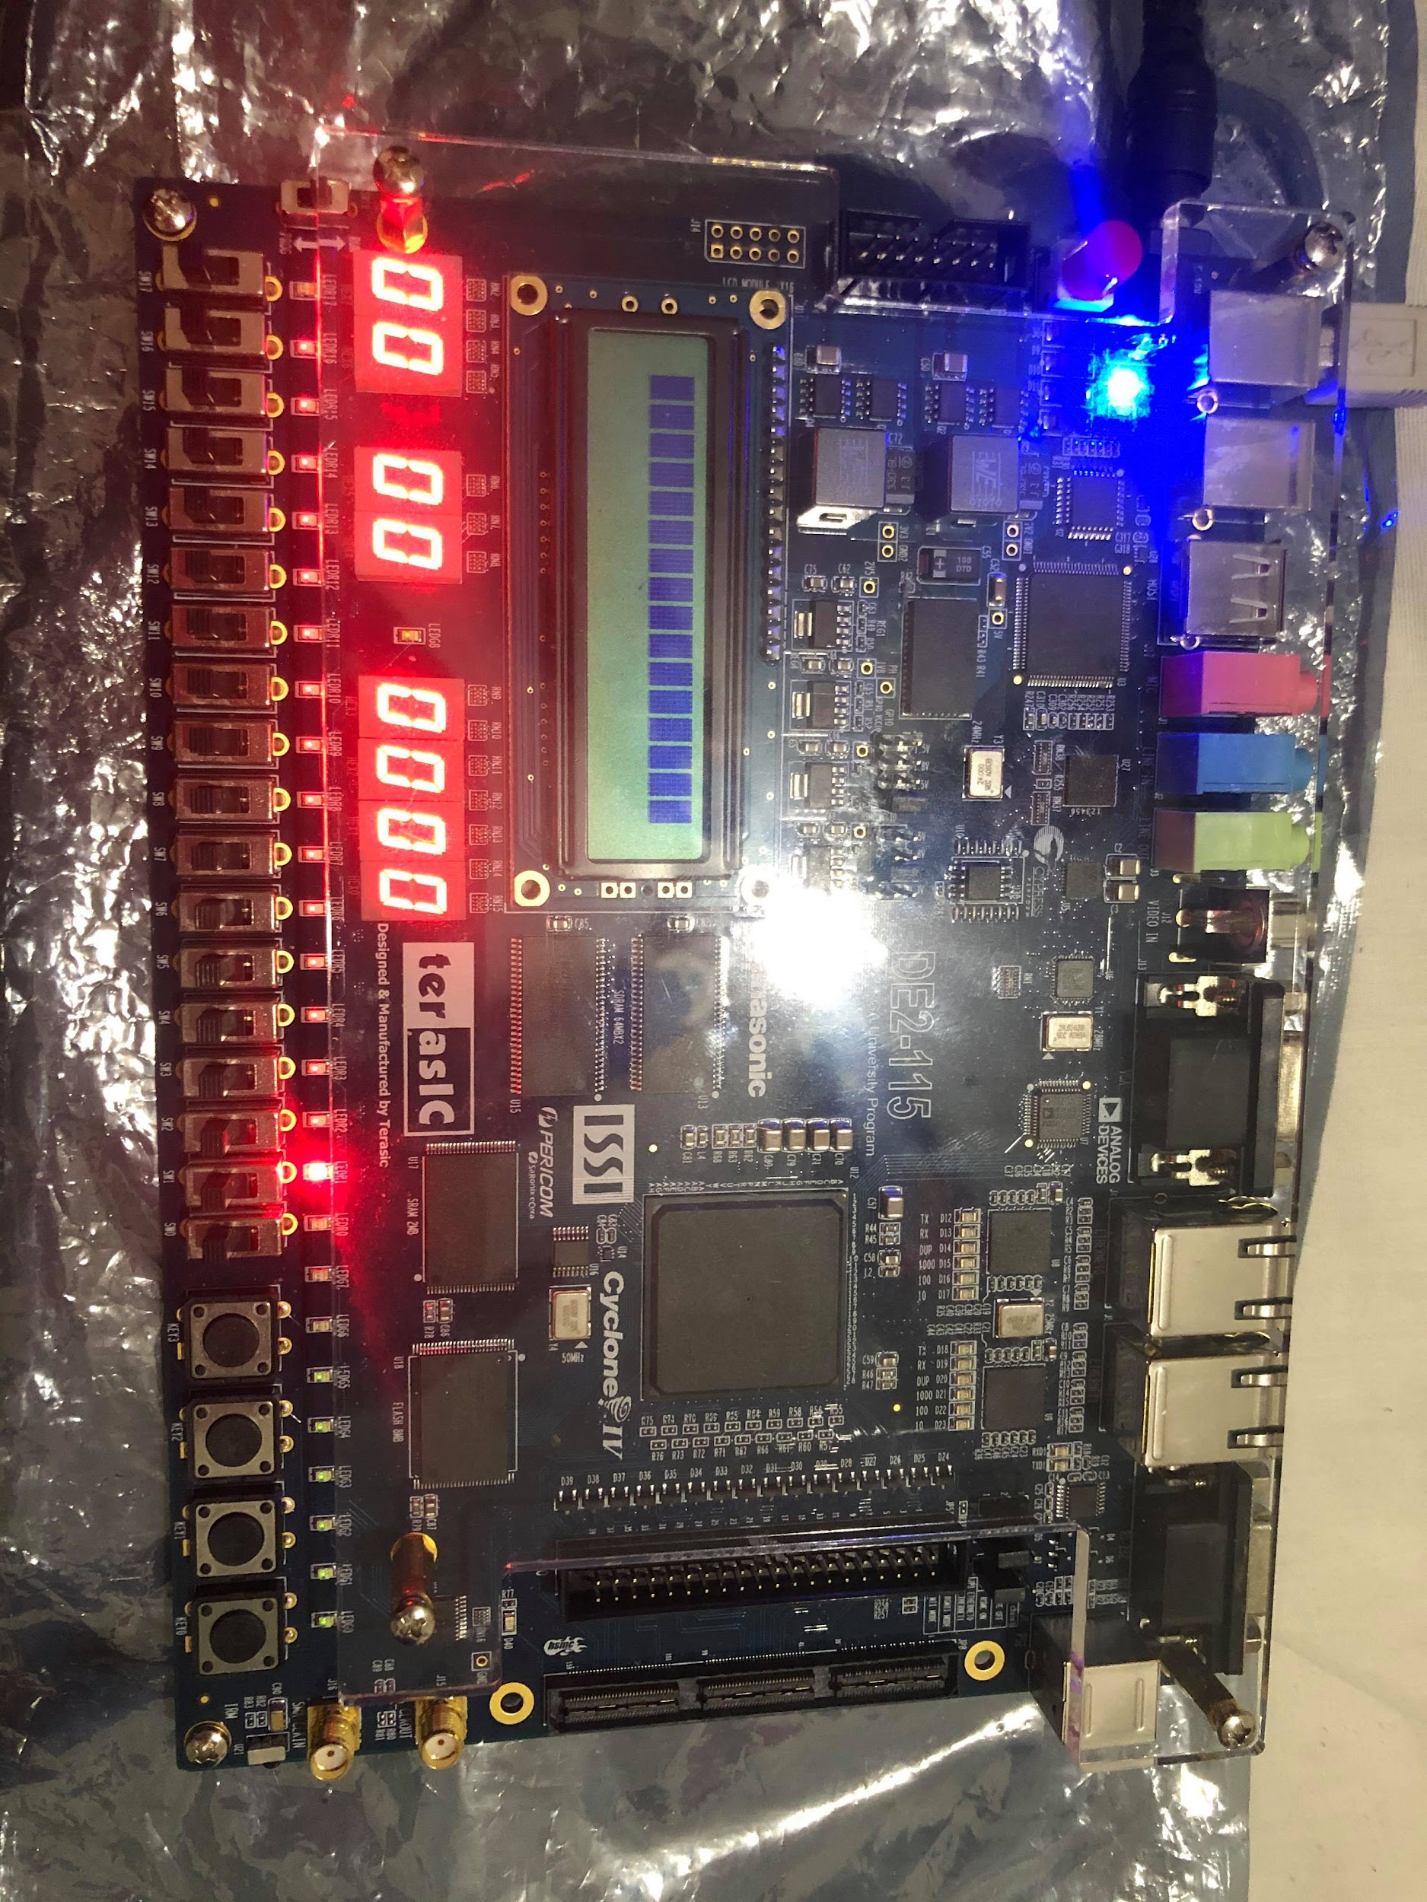

*Figure 1. Start Up Screen*

1. First, the player must press the reset button to initialize the game.

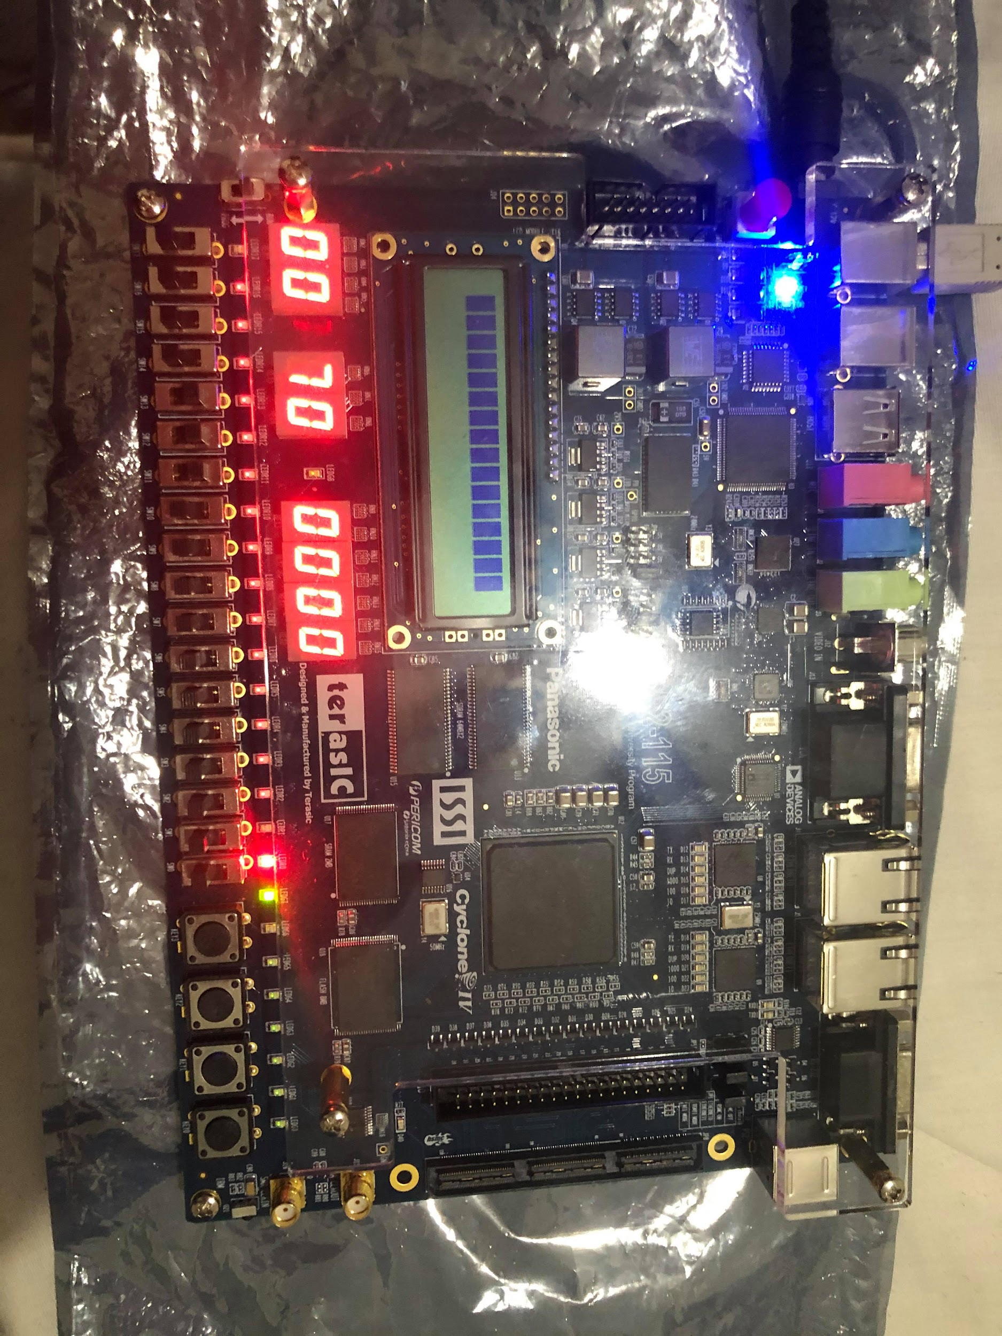

*Figure 2. Correctly Entered User ID*

2. The player must first enter their correct 4-digit ID they were given using the ID/Password switches and load button. They will enter their ID one digit at a time, setting the switches and pushing the load button for each digit.

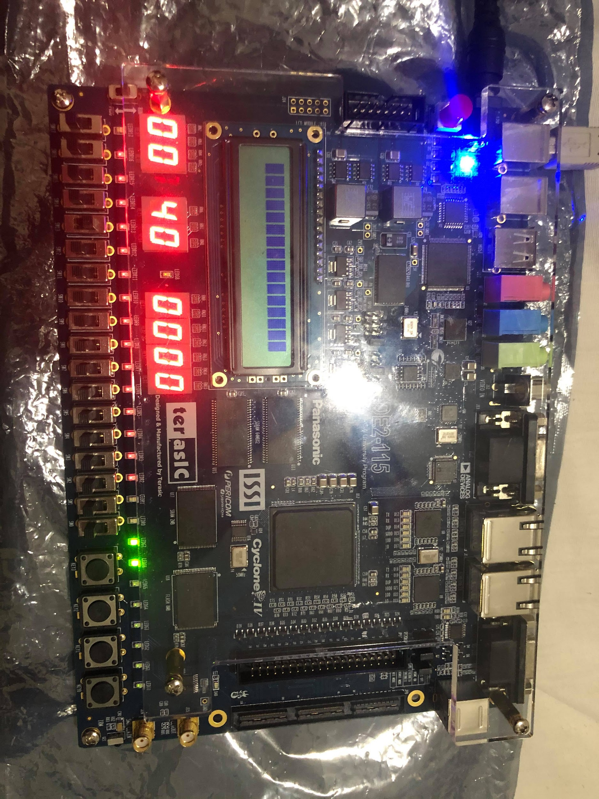

*Figure 3. Correctly Entered Password*

3. Next, the player must enter the correct 5-digit password assigned to the game ID using the ID/Password switches and load button. They will enter their password one digit at a time, setting the switches and pushing the load button for each digit.

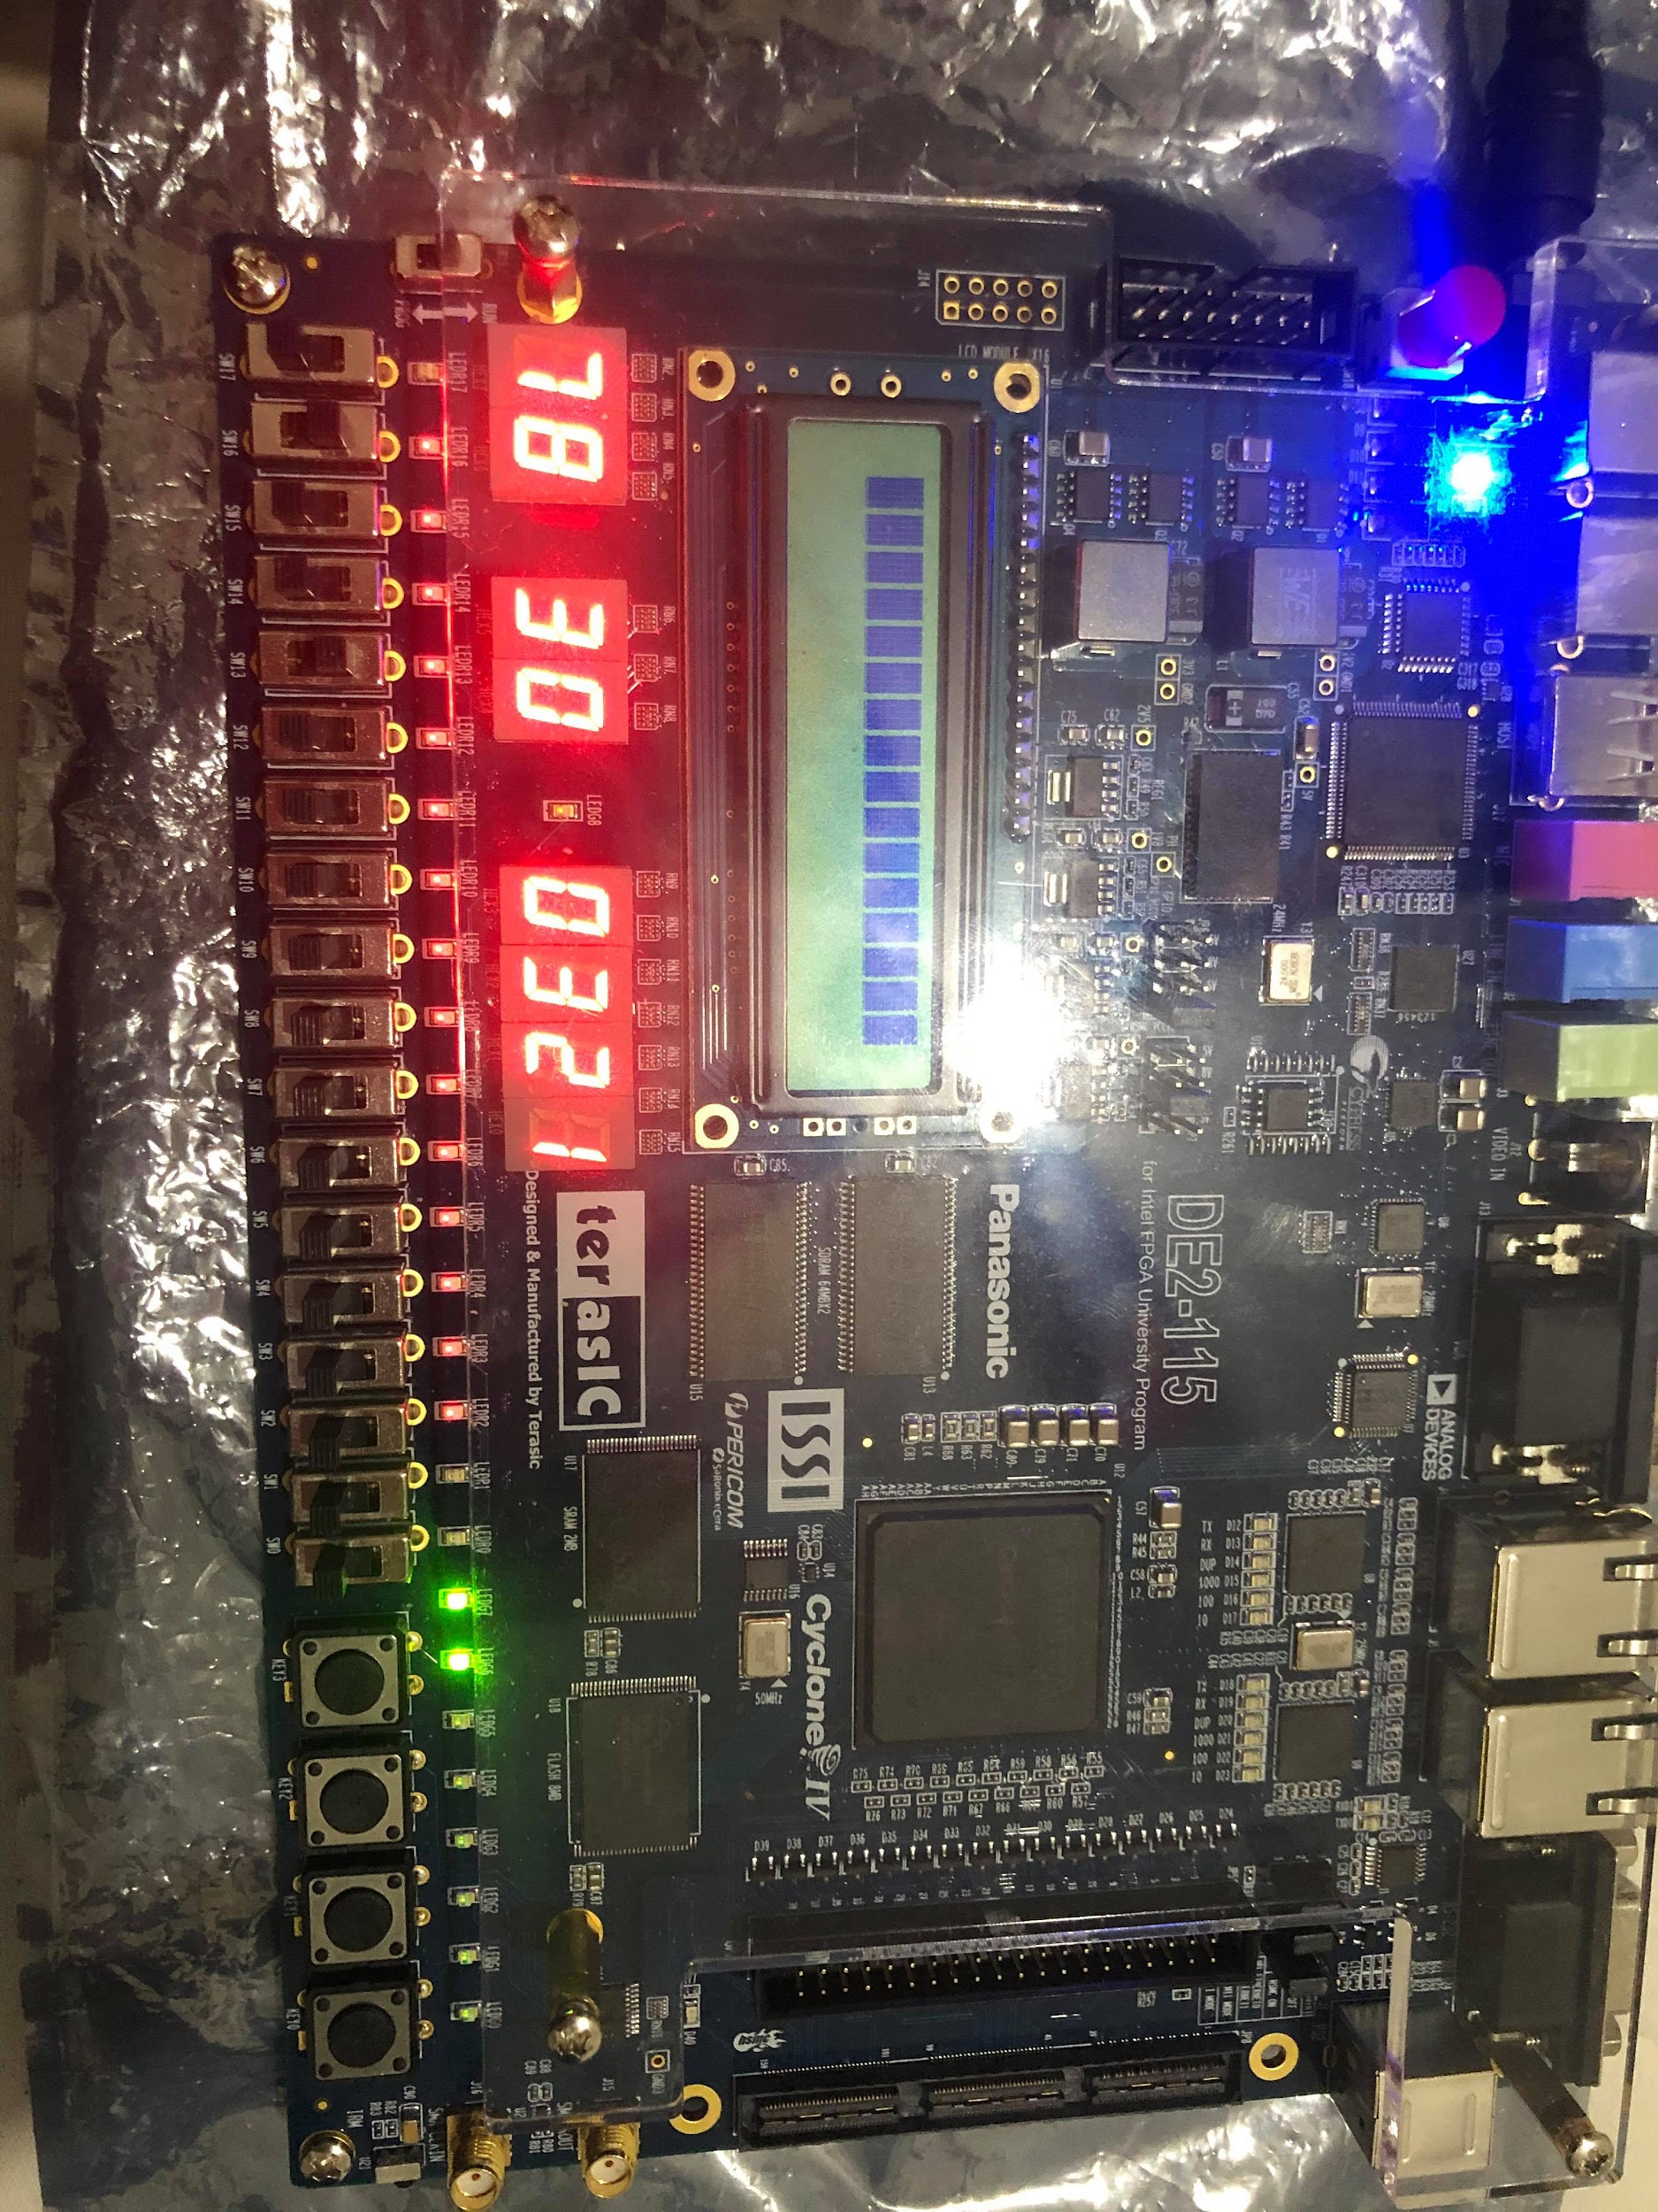

*Figure 4. Timer Loaded (Easy Difficulty) and Game has Begun*

4. Once they are given access, the player will now be able to toggle the level difficulty in order to play. There are three levels of difficulty ranging from easy, medium, and hard. The difficulty level will automatically assign the timer accordingly. They will use the difficulty set switches on the far left of the FPGA board. For the easiest level (01), the player will receive 90 seconds to play. The medium level (10) will provide 60 seconds to play. And lastly the hardest level (00 or 11) will provide only 30 seconds to play.

5. Once the difficulty switches have been set to the user’s choosing, they will then press the load button twice to first set the time and then to start the timer.

6. Once the timer has begun counting down, the user will be presented with the time remaining in the far left seven segment displays as well as the five game screens required to play. The main game screen is located in the left middle seven segment display while the four game screens are located on the right four seven segment displays. They are labeled accordingly to Figure 1 above.

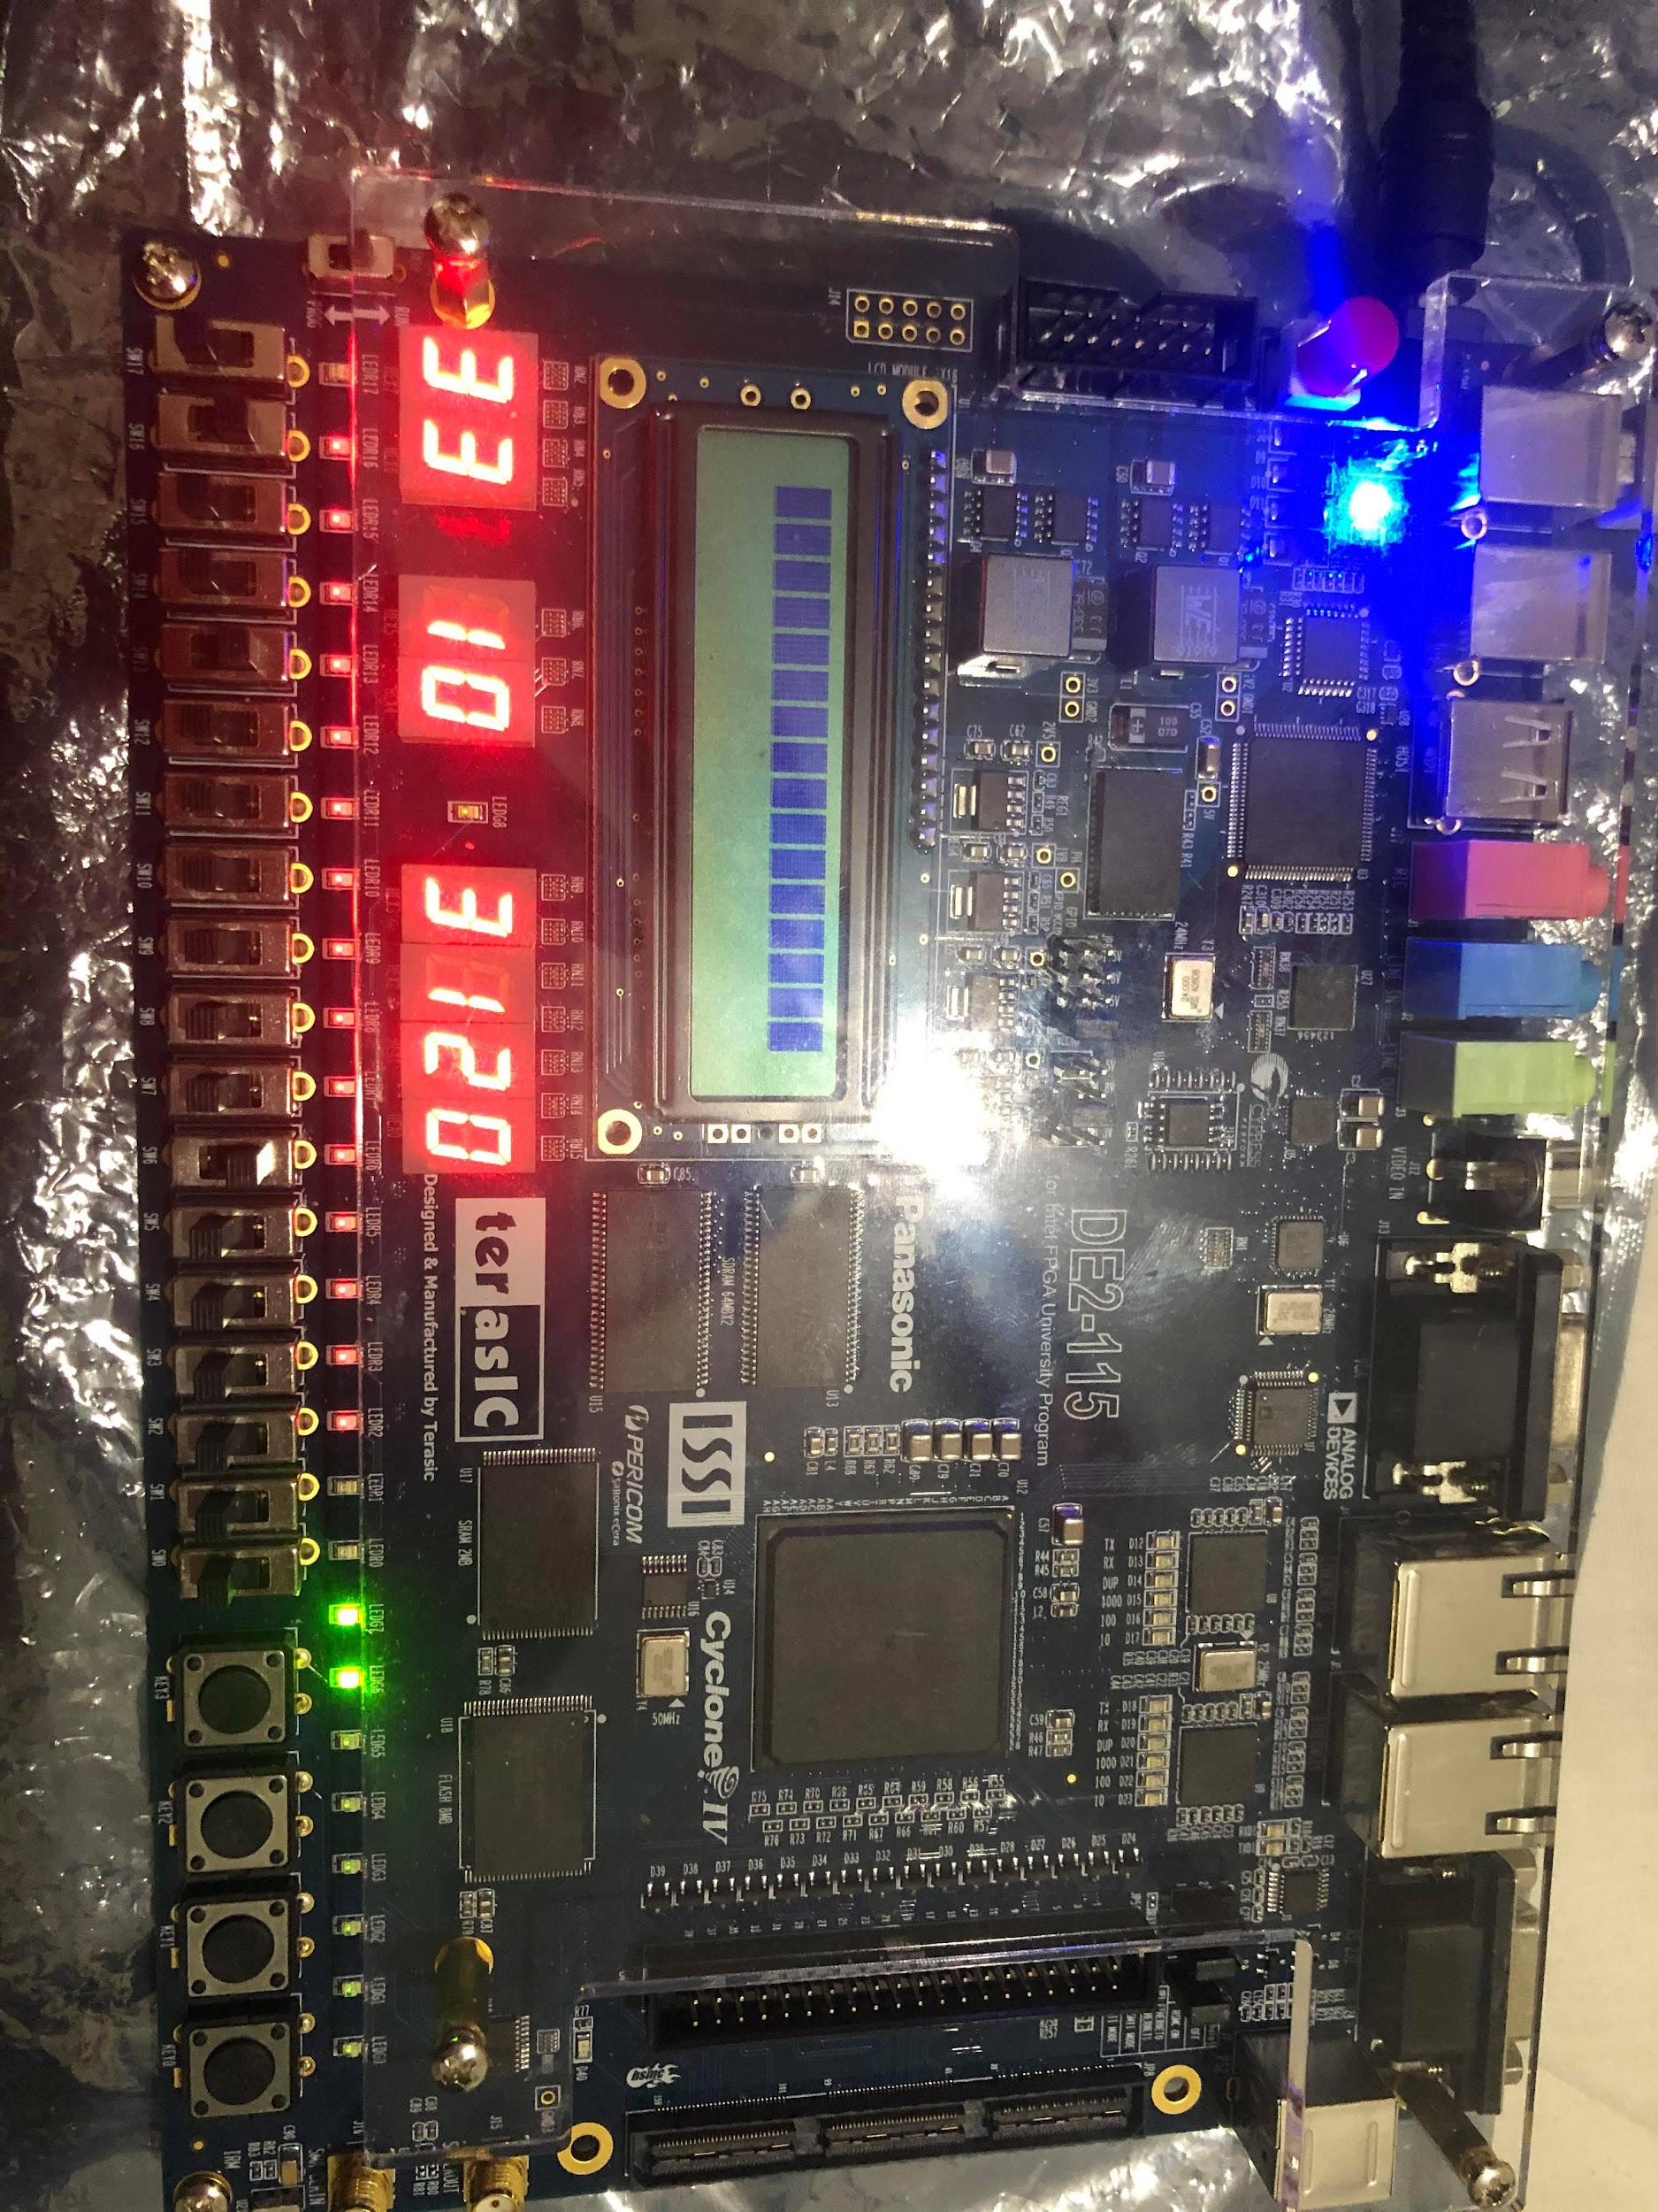

*Figure 5. Correct Input Loaded*

7. The user will follow the instructions that were mentioned earlier in this guide and provided to them by their assistant. They will use the designated game switches and game button in order to play.

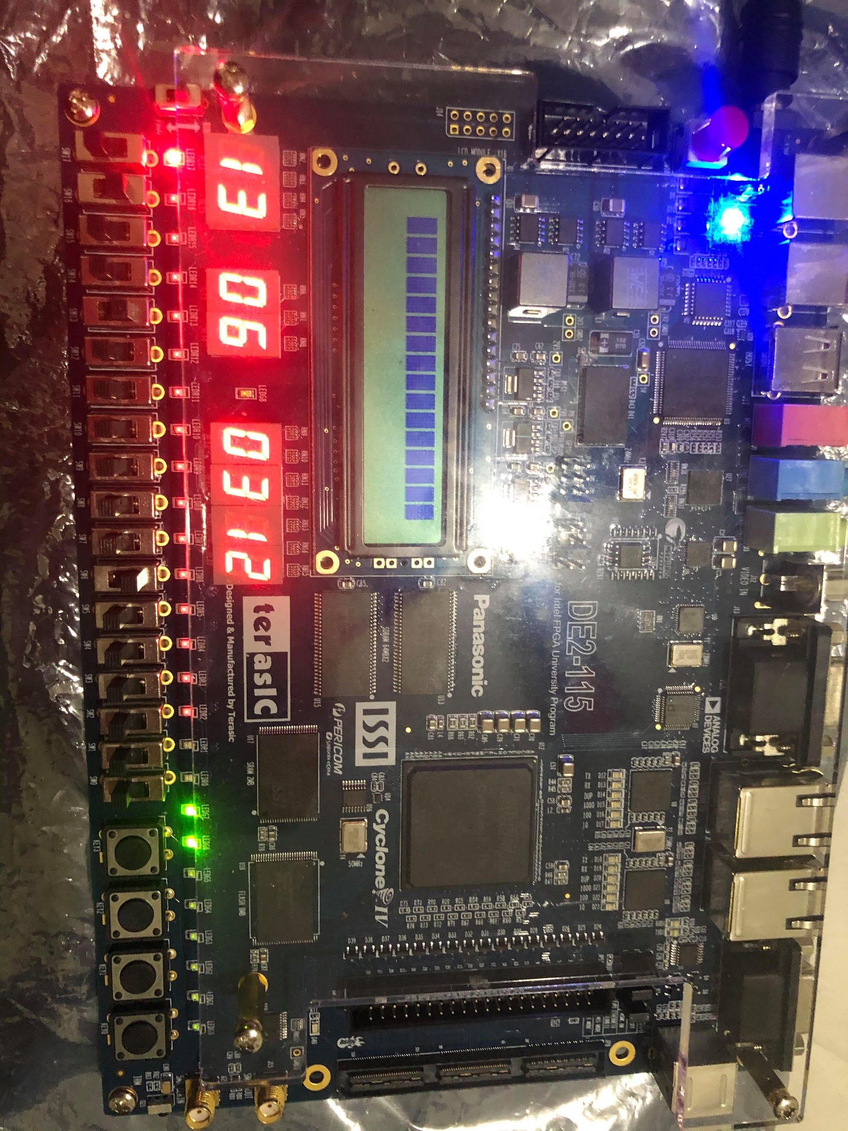

*Figure 6. Game Over State*

8. If for any instance the user chooses the wrong value or the timer has run out, the game will end and the user will obtain as many points as the number of stages they have completed multiplied by the level of difficulty that they chose. This will be indicated by a red LED on the far left of the FPGA that will appear when this event has occurred. Each stage completed, will provide 5 points to the player for a maximum of 20 points for each stage. The difficulty multiplier will multiply their base score by 1x for easy, 2x for medium, and 3x for hard.

9. When the game has finished, the player will be able to view the most recent high score along with the game ID of that player by pressing the high score button. The score will be shown in the middle two seven segment displays and will be followed by the game ID of the user in the four seven segment displays to the right.

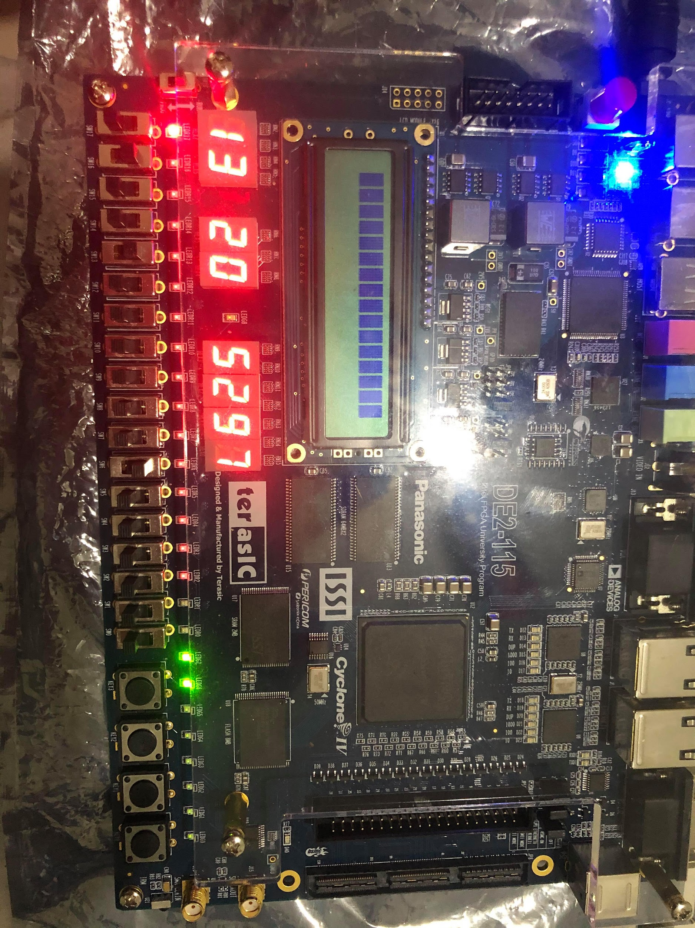

*Figure 7. High Score View*

10. If they do not decide to press to view the high score, the player can press the load button once to return to the difficulty configure stage as mentioned in instruction # 5 and replay the game.

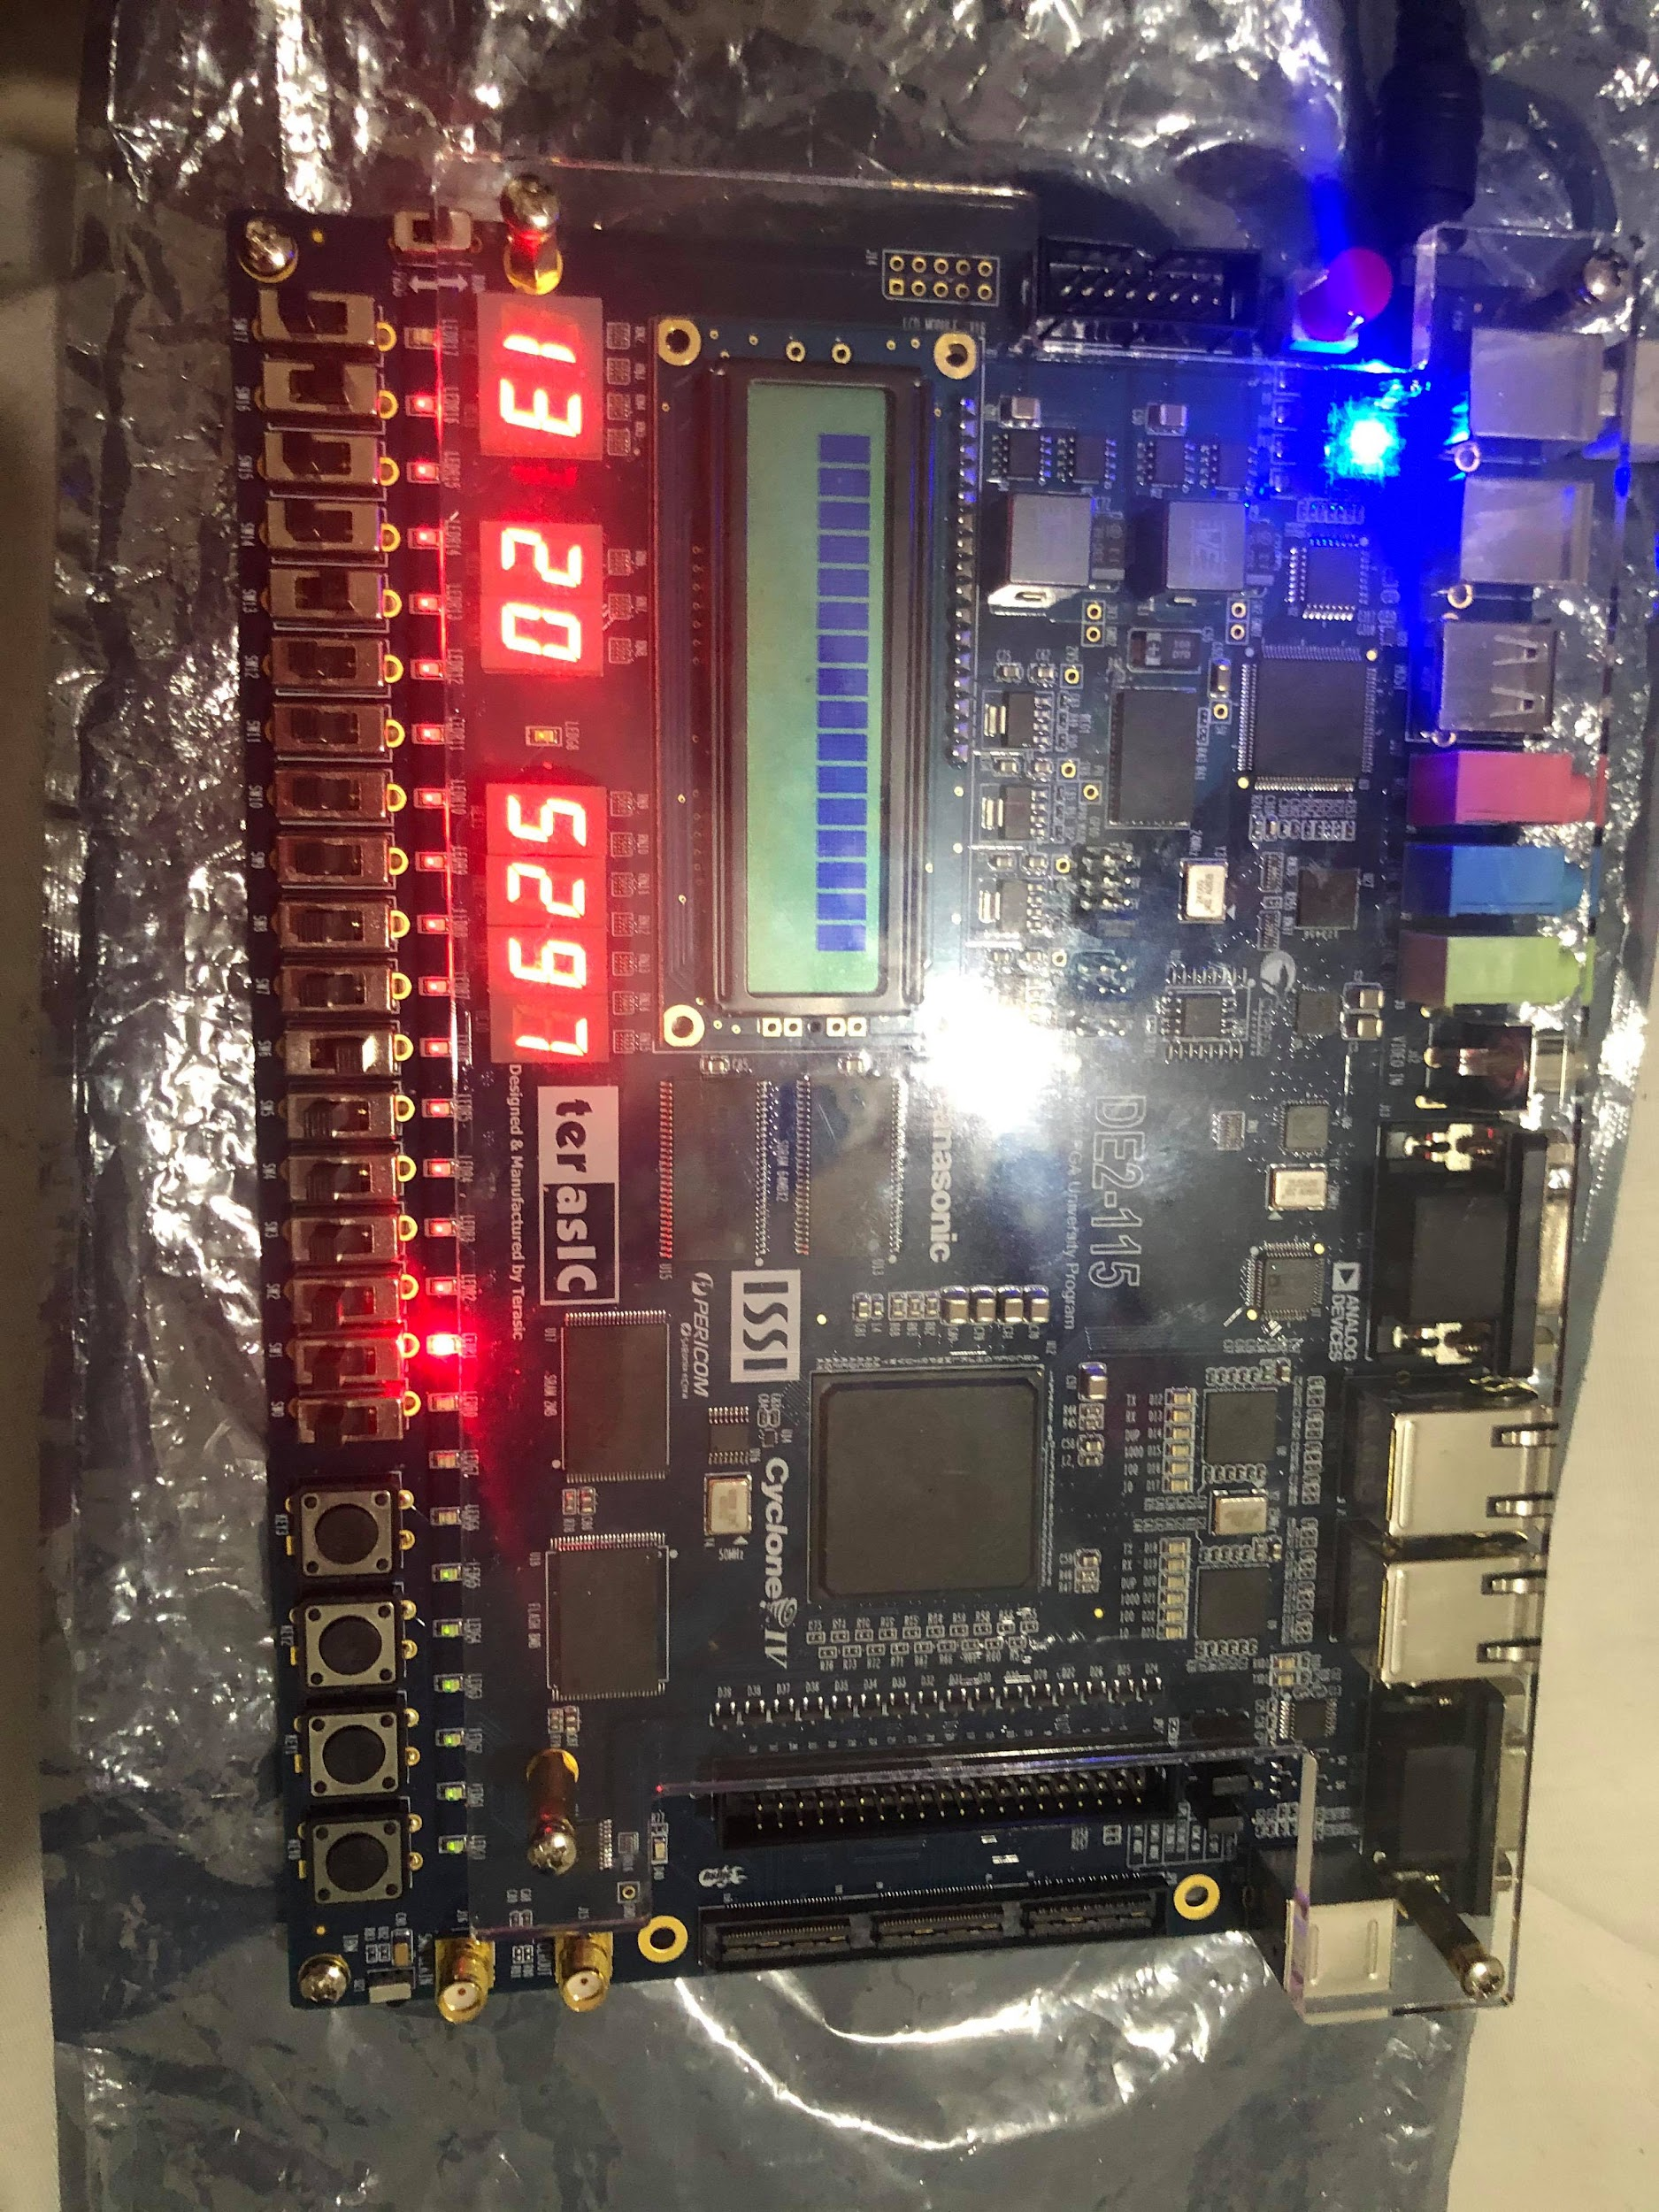

*Figure 8. Log Out*

11. They can also press the game button to log out and allow another user to play.